

Officers’ Side of the Joint Negotiating Committee for Chief Officers of Local Authorities: England and Wales

JNC PAY CLAIM 2026/27

The JNC Officers’ Side is submitting the following pay claim for our members covered by the Joint Negotiating Committee (JNC) for Chief Officers of Local Authorities:

- An increase at of least 10 per cent or an increase that is no less favourable to Chief Officers than the NJC claim – as a step towards pay restoration*
- An additional day of paid leave to align annual leave with NJC terms.

- Jointly agree and circulate a national survey on the levels of stress, workload pressures, and unpaid overtime experienced by Chief Officers.

Key points from our claim

Chief Officers deserve a pay rise.
- The pay of Chief Officers has fallen in real terms since April 2008 while comparable private sector rates have increased.
- Local authorities are suffering from a staff shortage at all levels across the country, exacerbating the work of Chief Officers.
Cost of living
- The December 2025 12-month RPI rates is 4.2 per cent and the CPI 12-month rate is 3.4 per cent.
- Last year’s settlement remained below inflation and further compounded the issue of our members facing real terms losses to their wages.
- ONS figures show overall UK household costs rose by 4.1% in the year to September 2025; this is an increase from 4.0% in the year to June 2025, and costs for households with children grew by 4.1% in the year to September 2025
- The OBR forecasts that RPI will average 3.7 per cent in 2026, along with mortgage interest rates rising to 5 per cent by 2027.
Overtime and wellbeing
- Our members report extremely high rates of unpaid overtime working, alongside the strain of stress and anxiety associated with leadership during a time of great financial pressure.

Chief Officers’ pay has been eroded and is no longer competitive with external rates for equivalent roles. The Trade Union Side calls on JNC employers to recognise this contribution and make our members an offer of 10 per cent and additional day of annual leave – or an increase that is no less favourable to our members than the NJC Green Book claim.

Link to the NJC Green Book claim
The Officers’ Side continues to see a close connection between the NJC and the JNC claims. As with last year, we aim to secure justified increases for Chief Officers and Green Book staff in tandem whilst respecting differentials, not at the expense of the other.
We maintain our position of agreement with the LGA in promoting a single organisational ethos by treating Chief Officers ‘the same or very similar to rank-and-file staff.’
We ask that this claim be read in conjunction with the arguments put forward in the main NJC claim, and that an offer is made that is either 10% or no less favourable to Chief Officers than Green Book workers.

Pay Comparability
The Local Government Association ‘Chief executive and chief officer pay survey’ of 2018 showed that pay had fallen behind the equivalent in the NHS and Further and Higher Education. To date, the LGA has not published results of an updated survey eight years on, suggesting that one has not been conducted, despite intentions.
Chief Officers’ pay has fallen behind comparable public and private sector rates. This dynamic is not new – the gap has only widened since the Communities and Local Government Select Committee said a decade ago that that:
‘Salary levels for local government sector posts are significantly lower than those in the private sector … even taking account of enhanced pension provision, packages remain much lower for a top council post when compared to the packages on offer for top private sector staff.’
Deloitte published findings that by September 2025 CEO pay of FTSE 250 companies had increased by 3 per cent, with an average median CEO ‘total single figure’ remuneration of £1.67m for 2024.
The most recent statistical modelling on pay for comparable jobs remains the ONS modelling published in September 2020, which found that when the differential for pay including overtime and bonuses was estimated, overall public sector wages were 3 per cent lower than comparable private sector rates (when controlled for employee characteristics).
The assessed differential is even less competitive for senior and/or highly skilled staff in large organisations (those employing more than 500 people): the wage differential for ‘upper skill groups’ was estimated to be -10.5 per cent, and for ‘upper-middle skill groups’ the differential was estimated at -14 per cent. The median hourly pay rate for ‘Managers, directors and senior officials’ was 14.8 per cent lower in the public sector.
ONS modelled estimate of the public/private percentage pay differential – gross pay including overtime and bonuses

Equality impact
It is noted that the gender pay gap has now tipped to 51 per cent of the top 5 per cent of earners being women. Whilst there have been improvements the number of the top 5 per cent earners who are identified as non-white is 11 per cent, according to the latest figures held by the LGA. The extent of the disability pay gap is unclear, as the LGA did not collect figures on this characteristic. However, the Trade Union side has reason for believing that disabled workers are underrepresented in Chief Officer grades.
We call upon the Employer Side again to undertake meaningful joint work with the Trade Union side to assess the extent of, and close, the gender, ethnicity, and disability pay gaps in Chief Officer grades.

Chief Officers’ Pay
Chief Officers’ pay was frozen for five years following the imposition of pay constraints in local government and the gap has never been recovered. While the Trade Union side recognises that settlements have been targeted at lower-paid local government workers, the real-terms erosion of Chief Officer rates has been severe. Our members in these grades have experienced the sharpest real-terms cuts in local government, which is already the lowest-paying part of the public sector.
Inflation has fluctuated and with the rise at the end of 2025, the 3.2 per cent settlement will not have helped overcome the real terms losses our members have experienced from the years of austerity.
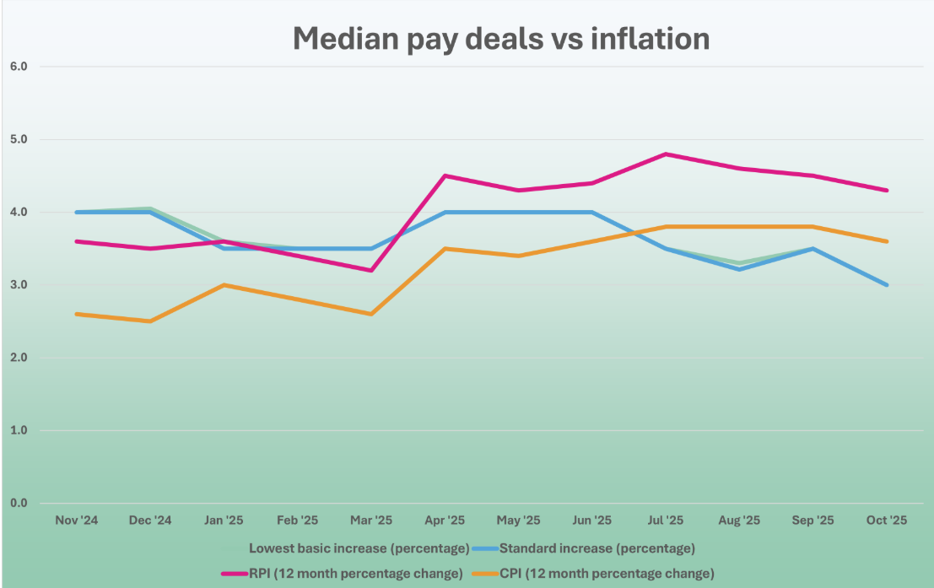
(Source: Labour Research Department, Payline release November 2025)

Cost of living
Cost of living pressures will remain elevated in the year ahead. The OBR forecasts that RPI will average 3.7 per cent in 2026, along with mortgage interest rates rising to 5 per cent by 2027.

This claim must be read against both the immediate context of uncompetitive local government pay rates and the long-term degrading of Chief Officers’ pay since 2008. The effective functioning of local government services requires dedicated senior managers, who are under exceptional strain as the pandemic gives way to severe funding pressures. A pay increase in line with this claim is in the wider interests of local government services.

Workload and work-life balance
Fifteen years of austerity has significantly added to the stress levels and workload burdens of Chief Officers. Recruitment and retention of staff continues to place our members under stress. The continued trend of decreasing headcount with 176,000 or 16 per cent fewer FTE roles than the previous 10 years, exacerbates the workloads and overall morale of our members. They are having to run services with fewer resources and necessary capital investment with a wider workforce who are acutely feeling the cost of living and working conditions stresses.

The LGA published that 94 per cent of councils are struggling with recruitment and retention difficulties. It appears from top to bottom, local authority workers are pushed to the limit to deliver the vital services our communities deserve.

The results of our surveys prove such in the below appendix.

The pressure of balancing competing priorities while meeting statutory duties is having a severe effect on the health and wellbeing of many of our members.

The majority of our members continue to work beyond their contracted hours, often not finding any way of taking that time back in lieu. Good people, who are dedicated public servants, will burn out quickly without addressing these matters. Our communities and wider council workers deserve a healthy leadership to ensure that the services they deliver keep us safe and prosperous.

We believe that pay awards should be fully funded, and we ask the Employer Side to work with us to lobby central government for a more favourable funding settlement.

Conclusion
Local Government relies upon its Chief Officers. As the Local Government Association has said:
“Great leadership from managers … is crucial to our shared vision for local government—efficient, accountable, reliable, and changing lives for the better. So now, more than ever, we need to ensure our officers are bold and ambitious leaders; equipped to tackle these challenges and lead local government to make a difference, deliver and be trusted.”
Chief Officers’ wages have fallen by more than third in real terms since 2008.
We are asking for an offer that is 10 per cent or no less favourable to our members than the main NJC claim as a step towards pay restoration, and action to close gender, ethnicity, and disability pay gaps.
Our members understand and are uniquely sensitive to the pressures that our public services have faced over the years of austerity. They have weathered pay freezes and below inflation awards – which is why our members are asking for an offer of 10 per cent and an additional day of paid annual leave, or an increase that is no less favourable to Chief Officers than the NJC claim.
Their goodwill and dedication to ensuring that our local authorities serve our communities in the additional hours they work, often unpaid, must also be rewarded by way of an additional day of paid leave to align annual leave with NJC terms.
We look forward to discussing this claim with the Local Government Employers.

Appendix – results of GMB and UNISON surveys
Survey responses on pay levels and recognition

· When asked whether they are well paid for the job they do, over one quarter of chief officers agreed (21.2% agreed and 3% strongly agreed), whereas the most (61.6%) disagreed (51.5% disagreed and 9.1% strongly disagreed). 15.2% neither agreed nor disagreed with the statement.
· While 47.1% of chief officers agreed or strongly agreed that they are valued by their employer, 29.4% either disagreed or strongly disagreed. This is three percentage points lower than the number of chief officers that disagreed or strongly disagreed (32.4%) with the same statement in the 2025 survey. 23.5% neither agreed nor disagreed.
· The majority (61.7%) of chief officers agree that pay has become an increasing concern for them as local authority chief officers (44.1% agree and 17.6% strongly agree). A further majority (61.8%) agree that the pay on offer to those in senior roles is causing recruitment and retention problems in their local authorities (41.2% agreed and 20.6% strongly agreed).

Hours of work

· While a majority (47.1%) of chief officers agree they have a good work-life balance 41.2% disagree (14.7% disagreed and 26.5% strongly disagreed).
· A significant majority (85%) said they constantly work more than their normal contracted hours and of these, one half (51.7%) work 1 – 5 extra hours in a typical week, 24.1% work 6 – 10 extra hours, and 17.2% said 11 – 15 extra hours.
· More than half (52.9%) of chief officers said there is no system in place to claim back time for the extra hours worked. For less than half (47.1%) of chief officers that do have a system in place, most said Time Off in Lieu (TOIL), or flexitime.
Additional comments include:
· Local Agile working plan. Very difficult to find time to take back my excess hours and use annual leave.
· Toil - no scope for extra pay.
· Planning time off in advance.
· Flexi - This works well as I get to take the time back with the children.
· Flexitime, although taking this back often causes time pressures further down the line.
New ways of working

· Most chief officers strongly agreed (23.5%) or agreed (26.5%) that they are now working in a more agile / hybrid manner, with more homework than two years ago and most agreed (24.2%) or strongly agreed (21.2%) that they are experiencing increasing costs because of increased homeworking.

References LGA, Written Evidence to the Housing, Communities and Local Government Committee’s inquiry into Local government chief officers' remuneration, January 2014 https://data.parliament.uk/writtenevidence/committeeevidence.svc/evidencedocument/housing-communities-and-local-government-committee/local-government-chief-officers-remuneration/written/5649.pdf
CLG Select Committee, Local Government Chief Officers' Remuneration, 12 September 2014, page 9 http://www.publications.parliament.uk/pa/cm201415/cmselect/cmcomloc/191/191.pdf
https://www.deloitte.com/content/dam/assets-zone2/uk/en/docs/services/tax/2025/your-guide-ftse-250-companies-2025.pdf
ONS, Public and private sector earnings: 2019, 23 September 2020 https://www.ons.gov.uk/employmentandlabourmarket/peopleinwork/earningsandworkinghours/articles/publicandprivatesectorearnings/2019#econometric-modelling-of-private-and-public-sector-earnings-analysis
LGA, Local government workforce summary data – November 2025, https://www.local.gov.uk/sites/default/files/documents/Local%20government%20workforce%20summary%20data%20-%20November%202025_0.pdf
https://www.lrd.org.uk/news/payline-release-november-2025
OBR, Economic and Fiscal Outlook: November 2025 https://obr.uk/docs/dlm_uploads/OBR_Economic_and_fiscal_outlook_November_2025.pdf
LGA, Local government workforce summary data – November 2025, https://www.local.gov.uk/sites/default/files/documents/Local%20government%20workforce%20summary%20data%20-%20November%202025_0.
https://web.archive.org/web/20150624215252/http://local.gov.uk/officer-development

