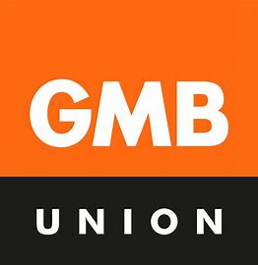

Dear [ADD NAME OF MP],
As your constituent and someone who has witnessed the impact of ill-fitting Personal Protective Equipment (PPE) on local workers safety, I am writing to you to urge you to support my union’s campaign PPE Fit For All.
PPE is the last line of defence – if it isn’t good enough, it leaves us exposed to disease, disabling physical harm, chronic health conditions and even death.
I, and other GMB reps around the country, have countless stories of workers, especially women, who are left unsafe due to ‘one-size-fits-all’ equipment.
[ADD PERSONAL/WORKPLACE PPE STORY OR DELETE]
The legislation around what is ‘suitable and sufficient’ PPE is weak, and lets employers get away with providing inadequate protection. We need your help to change that.
The world’s first inclusive PPE standard (BS 30417) has just been launched, and it could see a complete shift in our country’s approach to safety and equality in the workplace. But unless we embed it in our workplaces and laws, it could just sit and collect dust.
As my MP, I would like to ask, can you help make PPE Fit For All a reality?
You can access power that us workers cannot, so it would be very helpful if you would commit to supporting the campaign within the House of Commons whilst we do our best to get our employers to get on board.
Please let me know if you can support us.
Regards,
[ADD FULL NAME, WORKPLACE OR JOB ROLE, HOME ADDRESS]
If you’d like more information about the campaign or the specific legislative proposals GMB is calling for, please visit www.gmb.org.uk/ppe-fit-for-all or email lynsey.mann@gmb.org.uk or melanie.bartlett@gmb.org.uk

